

**BEACONHOUSE NATIONAL UNIVERSITY**

**SaafPakistan**

**PRJ-F23/329**

**Design Document**

**EXTERNAL SUPERVISOR**

**Mr. Abdul Wahab**

**INTERNAL SUPERVISOR  
  
 Ms. Shazia Rizwan**

**GROUP MEMBERS**

**Ali Sher F2020-158**

**Nouman Ali F2020-149**

**Mian Faizan Munawer F2020-148**

**SCHOOL OF COMPUTER & IT**

**September 2024**

**Introduction**

SaafPakistan is a revolutionary mobile app addressing waste management challenges in Pakistan. Key features include easy recycling pickup scheduling, a gamified leaderboard system for individuals and businesses, a friend connection feature, and rewards for recycling efforts. Corporate onboarding allows businesses to showcase environmental initiatives, gaining recognition as green companies. The app also offers educational content on effective recycling. The dashboard provides users with a summary of their achievements, aiming to streamline waste management, promote responsible waste disposal, and highlight the significance of sustainability practices.

**Technologies**

**WebApp:**

React

Udemy Course (https://www.udemy.com/course/the-ultimate-react-course/)

Firebase

Degree Course

**MobileApp:**

Flutter

Degree Course

Firebase

Degree Course

**C1 Diagram**

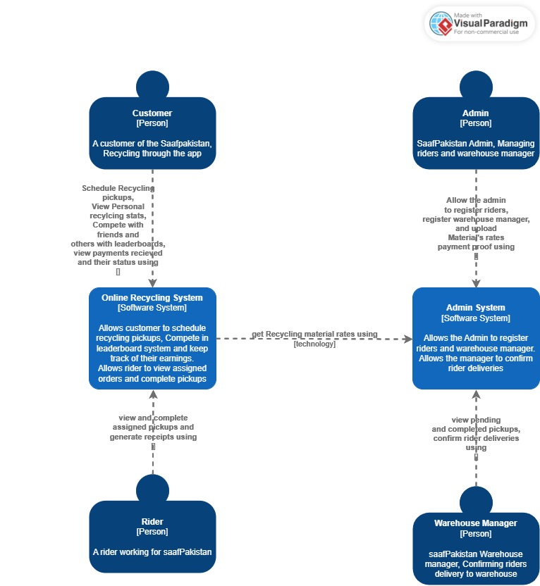

**C2 Diagram**

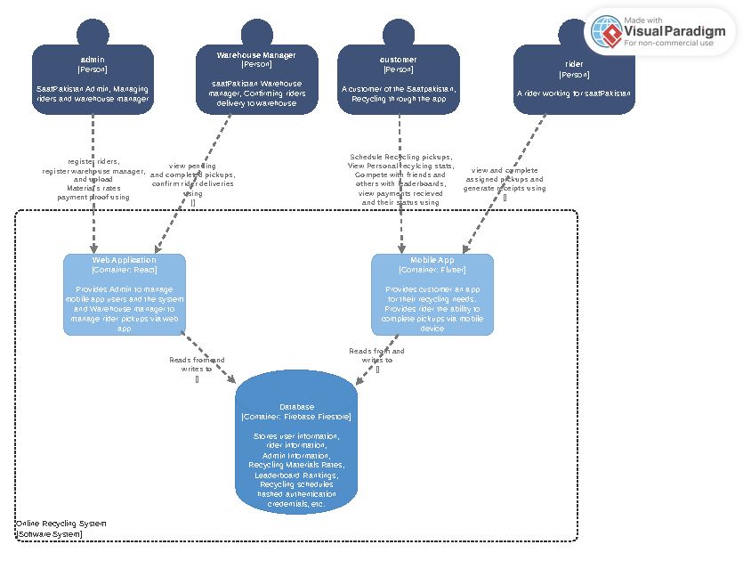

**C3 Diagram**

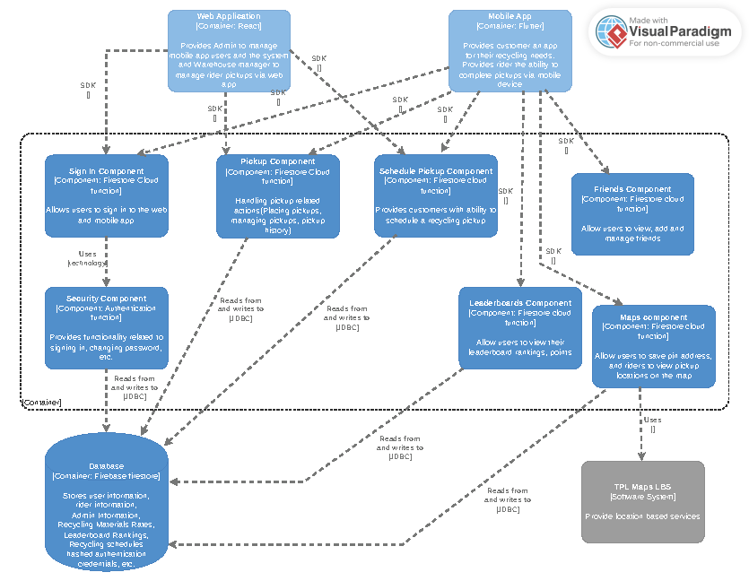

**Class Diagram**

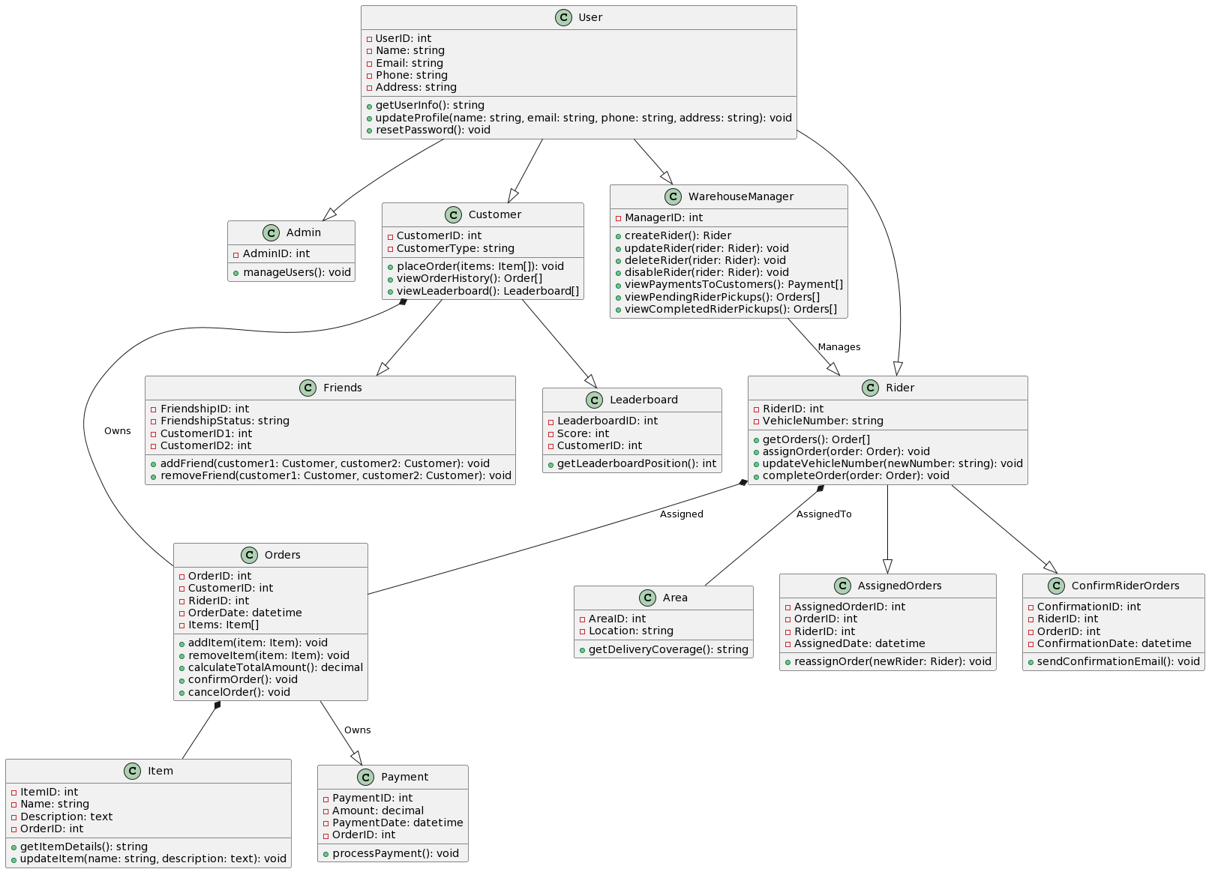

**DataBase Diagram**

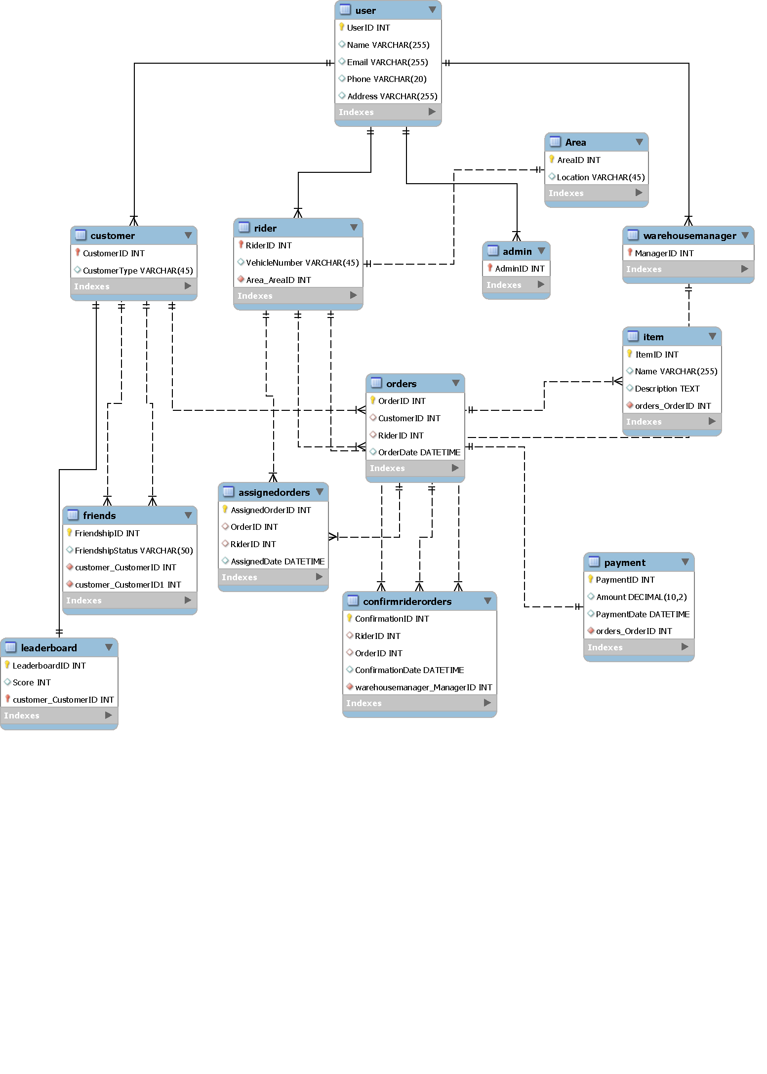

**Sequence Diagram**

**Schedule Pick-Up**

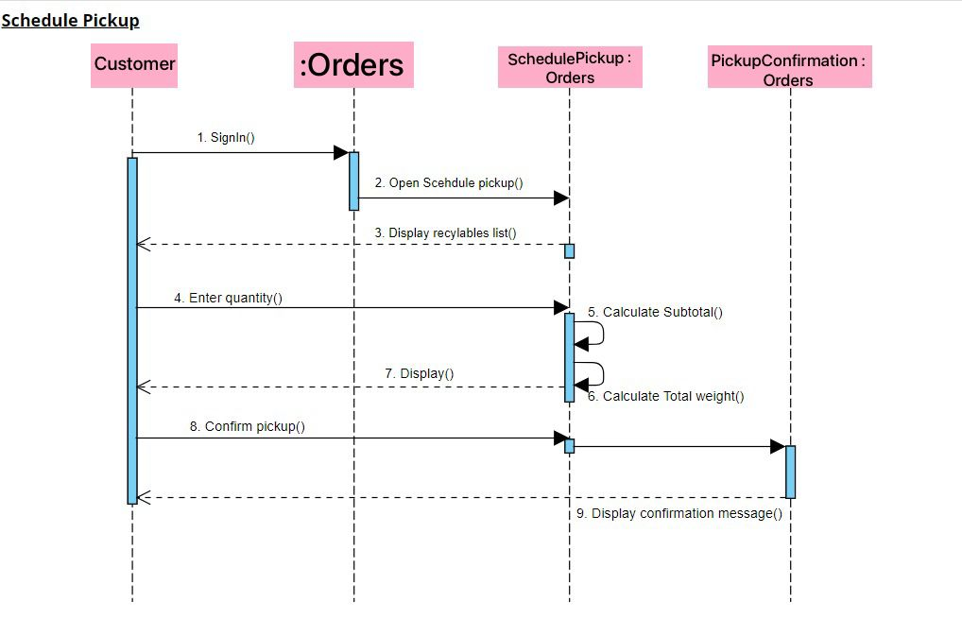

**Complete Pick-Up**

